Student worksheet

8.4 Acids have low pH. Bases have a high pH.

Pages 162–163 and 224–225

Acid and base chemical reactions

1 Summarise the differences between acids and bases in the following table.

|  |  |  |  |  |
| --- | --- | --- | --- | --- |
|  | Acids | | Bases | |
|  | Weak | Strong | Weak | Strong |
| What does it taste like? |  | |  | |
| What does it feel like? |  | |  | |
| What does it contain in its chemical structure? |  | |  |  |
| What does it read on the pH scale? |  | |  | |
| Colour in universal indicator? |  |  |  |  |
| What litmus paper should be used and what colour does it turn? |  | |  | |
| 3 examples that are found in the home |  |  |  |  |
| 2 uses around the home or in industry |  |  |  |  |

2 Label the following diagram of the pH scale.

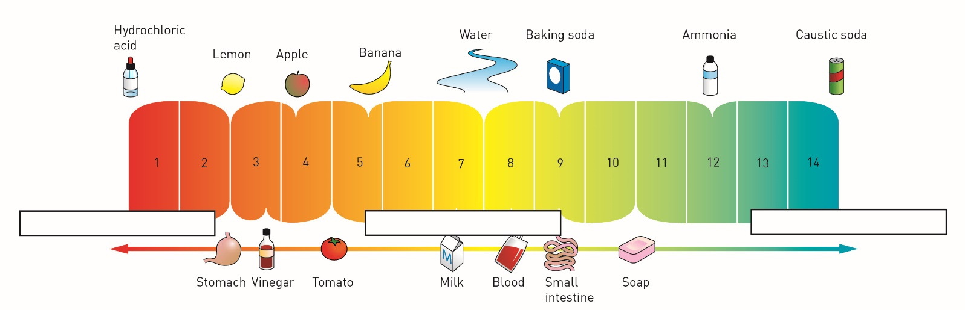

3 What do the colours on the above pH scale represent?

Extend your understanding

4 Your teacher puts 3 test tubes on your science bench and asks you to identify which is the salt solution, the acid solution and the alkali solution. Outline what you would use to determine the answer and what results you would obtain.

5 The following are results of some substances that have been tested in the science laboratory with a variety of indicators; red litmus, blue litmus and Universal indicator. Look at the results and complete the table below.

|  |  |  |  |  |  |
| --- | --- | --- | --- | --- | --- |
| Substance | What colour will red litmus paper turn? | What colour will blue litmus paper turn? | pH read on universal Indicator | Acid, base or neutral? | Example of a substance that it could be. |
| A |  |  | pH 7 |  |  |
| B |  |  | pH 4 |  |  |
| C |  |  | pH 2 |  |  |
| D |  |  | pH 11 |  |  |
| E |  |  | pH 8 |  |  |